**ROTATION**

clc;

close all;

clear all;

image = imread('graylenna.png'); %give a grayscale image

[m,n]=size(image);

angle = 45; %set angle here

rad = 2*pi*angle/360;

m_m = ceil(m*abs(cos(rad))+n*abs(sin(rad)));

n_n = ceil(m*abs(sin(rad))+n*abs(cos(rad)));

a1 = uint8(zeros(([m_m m_m])));

x_mid = ceil(m/2);

y_mid = ceil(n/2);

x1_mid = ceil((size(a1,1))/2);

y1_mid = ceil((size(a1,2))/2);

for i=1:m_m

for j=1:n_n

x=(i-x1_mid)*cos(rad)+(j-y1_mid)*sin(rad);

y=-(i-x1_mid)*sin(rad)+(j-y1_mid)*cos(rad);

x=round(x)+x_mid;

y=round(y)+y_mid;

if(x>=1 && y>=1 && x<=m && y<=n)

a1(i,j)=image(x,y);

end

end

end

imshow(image);

title('Original Image');

figure;imshow(a1);

title('Inverse Mapping algorithm');

**OUTPUT**

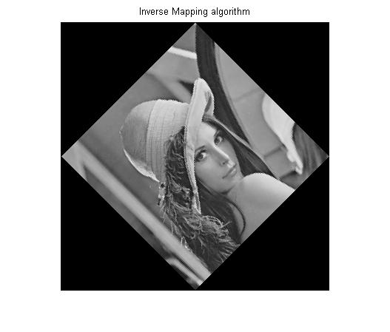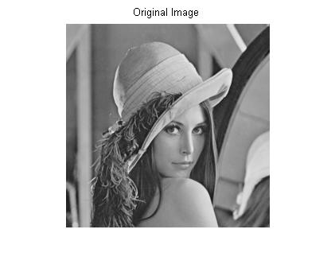

**LABELLING OF CONNECTED COMPONENT**

clc;

close all;

clear all;

image=imread('sample.png');

imshow(image);title('Original image');figure

%for grayscale

image=rgb2gray(image);

imshow(image);title('Grayscaled image');figure

%for binary

[m,n]=size(image);

a=logical(zeros(m,n));

frequency=zeros(1,256);

for i=1:m

for j=1:n

frequency(1,image(i,j)+1)=frequency(1,image(i,j)+1)+1;

end

end

[val,thres]=max(frequency);

for i=1:m

for j=1:n

if(image(i,j)~=thres-1)

a(i,j)=1;

end

end

end

img=mat2gray(a);

img=im2bw(img);

imshow(img);title('Binary image');figure

% % Create the label matrix % %

count = 1;

e = uint8(zeros(0,2));

ecount=1;

size_img = size(img);

label = uint8(zeros(size_img));

for i=1:size_img(1)

for j=1:size_img(2)

if img(i,j) == 0

label(i,j) = 0;

elseif img(i,j)==1

if ((img(i-1,j)==0) && (img(i,j-1)==0))

label(i,j) = count;

count = count + 1;

elseif ((img(i-1,j)==1)&& (img(i,j-1)==1))

label(i,j) = label(i-1,j);

if label(i-1,j) ~= label(i,j-1)

s = size(e);

flag = 0;

for z=1:s(1)

if e(z,1)==label(i-1,j)

flag = 1;

break;

end

end

if flag==0

e(ecount,1) = label(i-1,j);

e(ecount,2) = label(i,j-1);

ecount = ecount + 1;

end

end

elseif ((img(i-1,j)==1)|| (img(i,j-1)==1))

if img(i-1,j) == 1

label(i,j) = label(i-1,j);

else

label(i,j) = label(i,j-1);

end

end

end

end

end

% Connected compnents joined %

s = size(e);

for i=s(1):-1:1

label(label==e(i,2)) = e(i,1);

end

final = label2rgb(label);

imshow(final);

title('Extracted objects');

**OUTPUT**

